Help Wanted! Have you ever wanted to help Santa and be an elf?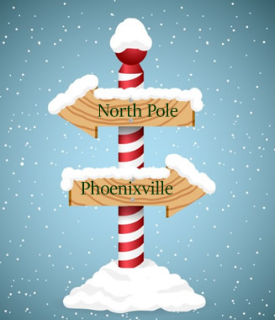
Did you know Santa lives in Phoenixville? That’s right, and she has a bunch of elves too! Yes, Santa is alive and well and this year is making her list and checking it twice and making wishes come true for local children. And thanks to Stirling Storage, Santa has a workshop RIGHT HERE!!
Our mission is to help every family enjoy the magic of Christmas and the holiday season.
We have a list of children and their wish lists at www.opelves.com
You can help in one of three ways:
- Adopt a child and purchase an item or more from their wish list (we suggest a budget of $150 per child), items can be dropped off at Stirling Storage, 305 Kimberton Road. Ask at the office for the Operation Phoenixville Elves dropoff.
  - Help purchase PJ’s, clothes, socks and underwear for children needing those
  - Purchase winter coats, boots and snow pants for those who need it
- Donate toward the cost of these items at our website, www.opelves.com
- Join us at one of our Community Wrapping Parties at the Great American Pub:
  - Dec. 10th, 12 to 5 pm
  - Dec. 17, 12 to 5 pm
Address: 148 Bridge St, Phoenixville, PA 19460
Phone: (610) 917-3333

For more information on helping, visit www.opelves.com

